INSTRUCTIONS
Please read the instructions carefully before doing the questions.
- You can use materials in your computer, notebook and text book.
- You are NOT allowed to use any device to share data with others.
Beside the above conditions, students must follow the following requirements:
- The work must complete by using Visual Studio 2022++
- The Framework must be .NET 8.0
- THIS PART IS VERY IMPORTANT, PLEASE READ IT CAREFULLY AND FOLLOW THE INSTRUCTIONS.
- You are given a database script (.sql file) in Zip file. Execute the script before doing questions.
- You must use the given solution. (SẼ ĐƯỢC GỬI QUA EMAIL)
- You are not allowed to add any more libraries via NuGet Package Manager into the given solution.
- Just one of above requirements is violated, your work will be considered as invalid.
On completion, submit the whole solution folder.
Before submitting, you can delete the folder [bin] in each project to reduce the size of the solution, to fit the requirements of PEA_Client.

Question 1 (4 points): Design a Vehicle Speed Adjustment System
Design a C# console application that meet the following requirements:
- Create an abstract class Vehicle with:
- Private fields: string name, int speed.
- Constructor: public Vehicle(string name, int speed) to initialize name and speed.
- Public properties: Name, Speed for get and set value of fields: name and speed.
- Abstract method: string DescribeMovement().
- Create a class Car that inherits from Vehicle:
- Implement DescribeMovement() to return: "[name] is driving at [speed] km/h".
- Create a class Bicycle that inherits from Vehicle:
- Implement DescribeMovement() to return: "[name] is pedaling at [speed] km/h".
- Declare a delegate SpeedAdjuster that takes an int parameter (current speed) and returns an int (new speed).
- Create a static class SpeedCalculator with two static methods:
int IncreaseSpeed(int currentSpeed): increases the speed by 10 (returns currentSpeed + 10).
int DecreaseSpeed(int currentSpeed): decreases the speed by 5 (returns currentSpeed - 5).
- Write a simple Main method to test your code.
- Students are required to write a simple Main function to test the functionalities of the program.
- Here's a suggestion for writing the Main method to test your code:
class Program {
static void Main() {
Car car = new Car("Toyota", 100);
Bicycle bicycle = new Bicycle("Phoenix", 20);

SpeedAdjuster adjuster = SpeedCalculator.IncreaseSpeed;
car.Speed = adjuster(car.Speed);
Console.WriteLine(car.DescribeMovement());

adjuster = SpeedCalculator.DecreaseSpeed;
bicycle.Speed = adjuster(bicycle.Speed);
Console.WriteLine(bicycle.DescribeMovement());
}
}
- Expected output when you use the Main function suggested above:
Toyota is driving at 110 km/h
Phoenix is pedaling at 15 km/h
- Note that: during grading, this Main function will be replaced by another Main function provided by the grader. Students must ensure that classes, methods, and delegates are defined accurately as required, so that the grader's Main function can operate without causing compilation errors.

Question 2. (6 points)
You are asked to write a WPF application that allows listing, adding, and editing employee's information in the database.
Note:
- In this question you are required to access database using Entity Framework Core
- 0 will be given to the work that not using database connection string in the file appsettings.json

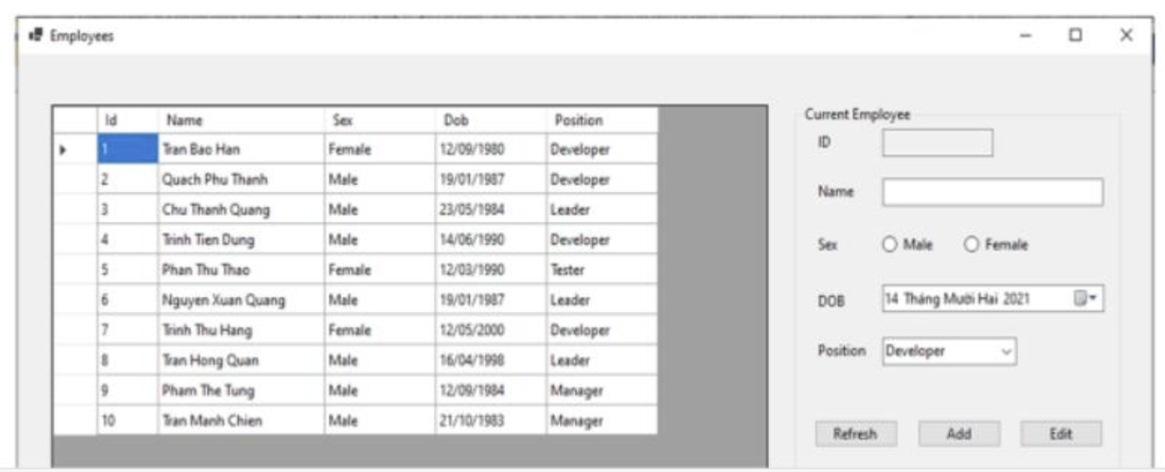
Figure 1 - Required form
- The window is designed as shown in Figure 1. The textbox of ID must be disable.
- (1.5 point) Load list of all employees in database into the data grid.
- (2 point)
In the combobox [Position] (in groupbox [Current Employee]), load all distinct position values that appear in table Employee in database.
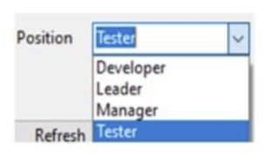
Figure 2 – Items of combobox [Position]
When user enters the employee's information into controls in groupbox [Current Employee] and presses the button Add, insert one more employee into database. The list of employees must be reloaded.
- (2 point) When user click on one cell in the data grid, load data of corresponding employee into controls in groupbox [Current Employee]. User can use Edit button for updating information of this employee in database. The list of employees must be reloaded.

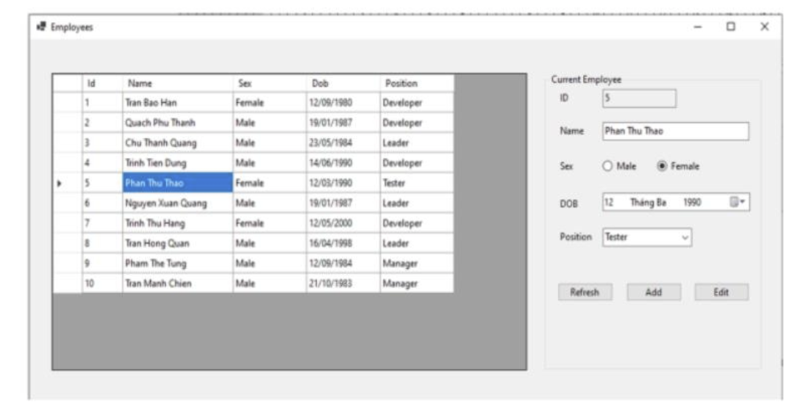
Figure 3 – Loading of employee's detail information.
- (0.5 point) When user click on button Refresh, clear all employee's detail information and reset this windows back to Figure 1.

